Project Design Phase
Solution Architecture

Date | 04 December2025
Team ID
Project Name | DocSpot-Medical Appointment Management System
Maximum Marks | 4 Marks

Solution Architecture:
The solution architecture of the Medical Appointment Management System is designed to deliver a secure, scalable, and seamless healthcare experience for patients, doctors, and administrators.
It supports efficient doctor discovery, real-time appointment updates, streamlined approval processes, and safe handling of medical records.
- Real-time visibility of doctor availability, enabling patients to book accurate and up-to-date time slots.
- Complete end-to-end workflow support: Registration → Approval → Doctor Search → Appointment Scheduling → Consultation → Prescription.
- Role-based authentication ensuring controlled access for Patients, Doctors, and Admins.
- Secure cloud-based storage for maintaining medical records, prescriptions, and patient history.
- Integrated notification system providing appointment confirmations, approvals, reminders, and status updates.
- Scalable cloud deployment, ensuring the system handles increasing users and workload efficiently.
- Data encryption to protect sensitive health information and ensure compliance with healthcare data standards.
- Unified management of online and offline consultations, allowing smooth coordination across different modes of appointments.

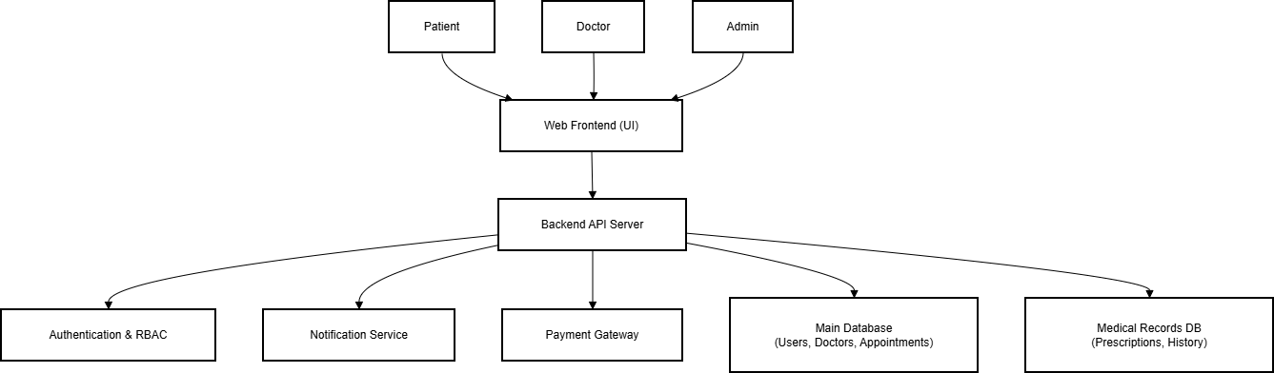
Example - Solution Architecture Diagram:

